Clinical SBAR REPORT Template
Situation/Background/Assessment/Recommendations
S | Pt. Initials: Age: Rm# Admit date:  MD (primary & consults):  Admission/Primary Dx:  Pt Changes or Pt Stable
B | Allergies:  Code Status: Isolation: Restraints: Other Precautions:  Medical Hx/Chronic Dx  Surgeries/Procedures:  Family Situation:
A | VS:  Neuro:  Pain w/location  AAO x3  Mood  Speech pattern  Hearing (aid)  Glasses/Blind  Neurocheck  CV:  Abn findings  Tele  Pacer  Resp:  Abn findings  02/L  Inc. Spir.  Endocrine:  Acc √ : time: BS: Coverage:  time: BS: Coverage: |  |  | Musculo/Skeletal  Activity/assist x_  Ambulatory Aids  GI:  Diet/Tolerance  Feeding Tube  Aspiration/Swallowing Precautions  Dentures  Last BM  GU:  I/O  Foley  Skin:  Drains  Wd/Pres. Ulcers  Braden Scale  IV Access & Fluids:
R | Plan for Shift: ADLs: C/P/S Daily Wgt:  Treatments:  Time for PT/Tests off Unit:  Estimated Date of D/C or Transfer  Teaching/Learning/Special Needs
Labs:
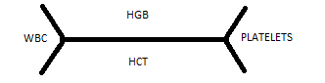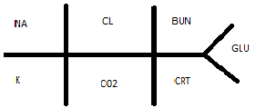
Other Diagnostics:

Medications: |  | Dose | Route |  | Indication | Time
1.
2.
3.
4.
5.
6.

